PROJECT REPORT FOR Foundations of Artificial Intelligence

SMART EXAM PLANNER
AI-Powered Study Planning with Live Data Integration

A PROJECT REPORT

Submitted by
2116240701587 - Vidyut Rao S
2116240701341 – Mukilraj S


October, 2026

BONAFIDE CERTIFICATE

Certified that this project report “Smart Exam Planner – AI-Powered Study Planning with Live Data Integration” is the bonafide work of “ S. Vidyut Rao (240701587)
& S. Mukilraj (240701341)” who carried out the project work under my supervision.

SIGNATURE OF THE FACULTY INCHARGE

Submitted for the Practical Examination held on

SIGNATURE OF THE INTERNAL EXAMINER

TABLE OF CONTENTS

CHAPTER NO. TITLE PAGE NO.

— | ABSTRACT
1 | INTRODUCTION
2 | LITERATURE REVIEW
3 | PROPOSED SYSTEM
3.1 | ARCHITECTURE DIAGRAM
4 | MODULES DESCRIPTION
4.1 | MODULE 1 – DATA INTEGRATION AND  QUESTION ANALYSIS
4.2 | MODULE 2 – AI STUDY PLANNER AND  QUIZ GENERATION
5 | IMPLEMENTATION AND RESULTS
5.1 | EXPERIMENTAL SETUP
5.2 | RESULTS
6 | CONCLUSION AND FUTURE WORK
7 | EFERENCES

ABSTRACT:

The Smart Exam Planner is an AI-powered study planning system designed to help students prepare for examinations in a structured and personalized manner. The system integrates academic resources such as syllabus, unit-wise notes, and previous-year question papers from RECDB and analyzes them to identify important topics and question patterns.

The system collects and processes academic content from the available resources and performs previous-year question paper comparison. Questions are categorized based on their marks, frequency, topics, and importance. Special attention is given to 2-mark questions for quick revision and 11-mark questions for detailed concept preparation.

The system uses Artificial Intelligence techniques to generate personalized study recommendations. The planner creates a day-wise study schedule based on the syllabus, topic importance, marks distribution, and available preparation time. It also provides AI-generated quizzes to help students test their understanding and identify weak areas.

The proposed system incorporates different AI and search techniques for intelligent planning. Breadth First Search (BFS) can be used for systematic topic organization, A Search* can be used for finding an efficient study path, Constraint Satisfaction Problem (CSP) with Backtracking can be used for allocating study tasks to available time slots, and Forward Chaining can be used to generate recommendations from identified facts and rules.

The system aims to provide students with a unified platform for academic preparation by combining live educational data, previous-year question analysis, AI-based quiz generation, and personalized study planning.

1. INTRODUCTION
Students often prepare for examinations using different resources such as syllabus documents, classroom notes, previous-year question papers, and online materials. Managing these resources manually can make examination preparation difficult and time-consuming.
In many cases, students are unable to identify which topics are more important, which questions are frequently repeated, and how much time should be allocated to each topic. A simple study timetable may also fail to consider the marks distribution and importance of individual topics.

The Smart Exam Planner is proposed as an AI-powered system that combines academic resources with intelligent analysis to create a personalized study plan. The system uses RECDB as a live academic data source containing syllabus, notes, and previous-year question papers.

The system analyzes previous-year question papers to identify frequently appearing topics and question patterns. Questions can be separated according to their marks, such as 2-mark and 11-mark questions. This helps students prepare short-answer topics separately from detailed long-answer topics.

The system then generates a day-wise study plan based on topic importance, syllabus coverage, marks distribution, and the available preparation period.

The major features of the system include:
- Live academic data integration
- Previous-year question paper analysis
- Important-topic identification
- Marks-wise question classification
- AI-generated quizzes
- Weak-topic identification
- Day-wise personalized study plan
- Syllabus-based preparation
- Intelligent study recommendation

2. LITERATURE REVIEW

Intelligent Study Planning Systems
Existing educational systems provide students with digital learning resources and timetable-based study assistance. However, traditional study planners generally create schedules without analyzing previous-year question patterns or topic importance.
The proposed Smart Exam Planner improves this approach by combining academic resources with question-paper analysis and AI-based planning.
Artificial Intelligence in Education
Artificial Intelligence can be used in education to provide personalized learning recommendations. AI-based systems can analyze student information and learning resources to recommend appropriate learning activities.
The proposed system uses AI techniques to analyze academic content, generate quizzes, and recommend study activities based on topic importance.
Previous-Year Question Paper Analysis
Previous-year question papers can provide useful information about frequently asked topics and question patterns. Analyzing questions across multiple years can help identify topics that require greater attention.
The proposed system compares previous-year questions and identifies repeated or important topics.
Search Algorithms for Study Planning
Search algorithms can be used to find an efficient sequence of activities. In the proposed system, search techniques can be applied to organize topics and generate an efficient study sequence.
Constraint Satisfaction in Scheduling
Study planning involves constraints such as available time, syllabus coverage, topic priority, and examination date. Constraint Satisfaction Problems can be used to allocate topics to appropriate time slots while satisfying these constraints.
Rule-Based Reasoning
Rule-based reasoning can be used to generate recommendations from known facts. Forward Chaining can process information such as topic frequency, marks, and weak areas to produce study recommendations.

3. PROPOSED SYSTEM

The proposed Smart Exam Planner is an AI-powered academic planning system designed to help students prepare for examinations using structured and personalized study schedules.

The system connects with the RECDB academic data source and uses available syllabus, notes, and previous-year question papers. The collected information is processed to identify important topics and question patterns.

The system performs the following major operations:

Collect academic data.

Process syllabus and notes.

Collect previous-year question papers.

Compare questions across different years.

Identify frequently appearing topics.

Categorize questions according to marks.

Generate important-topic lists.

Generate AI-based quizzes.

Identify weak areas through quiz performance.

Generate a personalized day-wise study plan.

The planner considers the examination date and available preparation time while creating the schedule.

3.1 ARCHITECTURE DIAGRAM
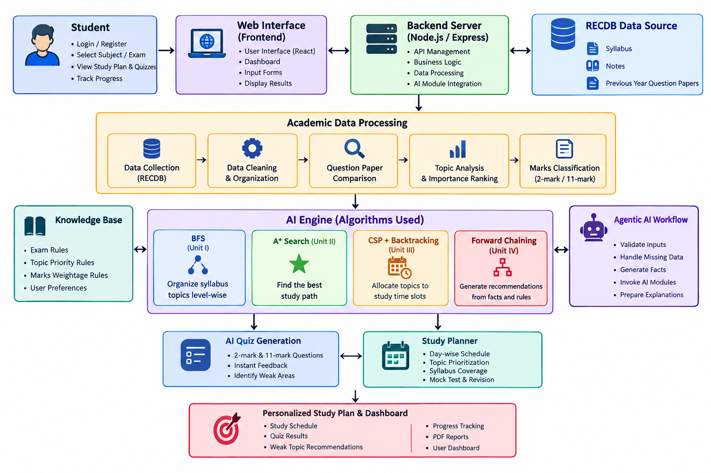
Figure 3.1: System Architecture of DuckPersona

4. MODULES DESCRIPTION
The Smart Exam Planner is organized into two major modules. The first module is responsible for collecting and analyzing academic resources, while the second module performs AI-based planning, quiz generation, and personalized recommendations.

4.1 MODULE 1 – DATA INTEGRATION AND QUESTION ANALYSIS
The Data Integration and Question Analysis Module is responsible for collecting academic information required for examination preparation.
The module obtains:
- Semester syllabus
- Unit-wise notes
- Previous-year question papers
- Question marks
- Topic information
The collected data is processed and organized according to subjects and units.
Previous-year question papers are compared to identify:
- Frequently asked questions
- Repeated topics
- Important units
- 2-mark questions
- 11-mark questions
- High-priority topics
The module generates structured information that is passed to the AI planning module.
Main functions:
- RECDB data collection
- Syllabus processing
- Notes organization
- Previous-year question collection
- Question comparison
- Topic frequency analysis
- Marks-wise classification
- Important-topic identification

4.2 MODULE 2 – AI STUDY PLANNER AND QUIZ GENERATION
The AI Study Planner and Quiz Generation Module uses the processed academic information to generate personalized learning recommendations.
The module analyzes topic importance and available preparation time.
It generates:
- Day-wise study plans
- Important-topic recommendations
- 2-mark quizzes
- 11-mark practice questions
- Revision recommendations
The planner considers the examination date and distributes the topics across available study days.
For example:
Day 1–2 → Important Unit I & II topics
Day 3–4 → Core topics
Day 5 → Quick revision
Day 6 → Mock test
Day 7 → Final revision
The quiz module can evaluate the student's answers and identify areas that require additional revision.
Main functions:
- Topic prioritization
- Study schedule generation
- AI quiz generation
- Weak-area identification
- Revision recommendations
- Exam preparation planning
- Personalized study schedule

5. IMPLEMENTATION AND RESULTS
The Smart Exam Planner is implemented as an AI-powered academic planning application. The system integrates academic data from RECDB with an analysis and planning engine.

The implementation consists of:
- Web-based user interface
- RECDB data source
- Academic data processing
- Previous-year question analysis
- AI planning engine
- Quiz generation module
- Personalized study planner

The system processes academic information and generates useful outputs such as important-topic lists, quizzes, and day-wise study schedules.

5.1 EXPERIMENTAL SETUP
The experimental setup consists of the academic data source, AI processing components, and user interface.
Input Data
The system uses:
- Subject syllabus
- Unit-wise notes
- Previous-year question papers
- Question marks
Processing
The system performs:
- Data collection
- Data organization
- Question comparison
- Topic frequency analysis
- Marks-wise classification
- Topic prioritization
- AI planning
- Quiz generation
AI Techniques
The project can demonstrate the following AI techniques:
Unit | Technique | Application
Unit I | BFS | Topic organization
Unit II | A* Search | Efficient study path
Unit III | CSP + Backtracking | Time-slot scheduling
Unit IV | Forward Chaining | Study recommendations
.
5.2 RESULTS
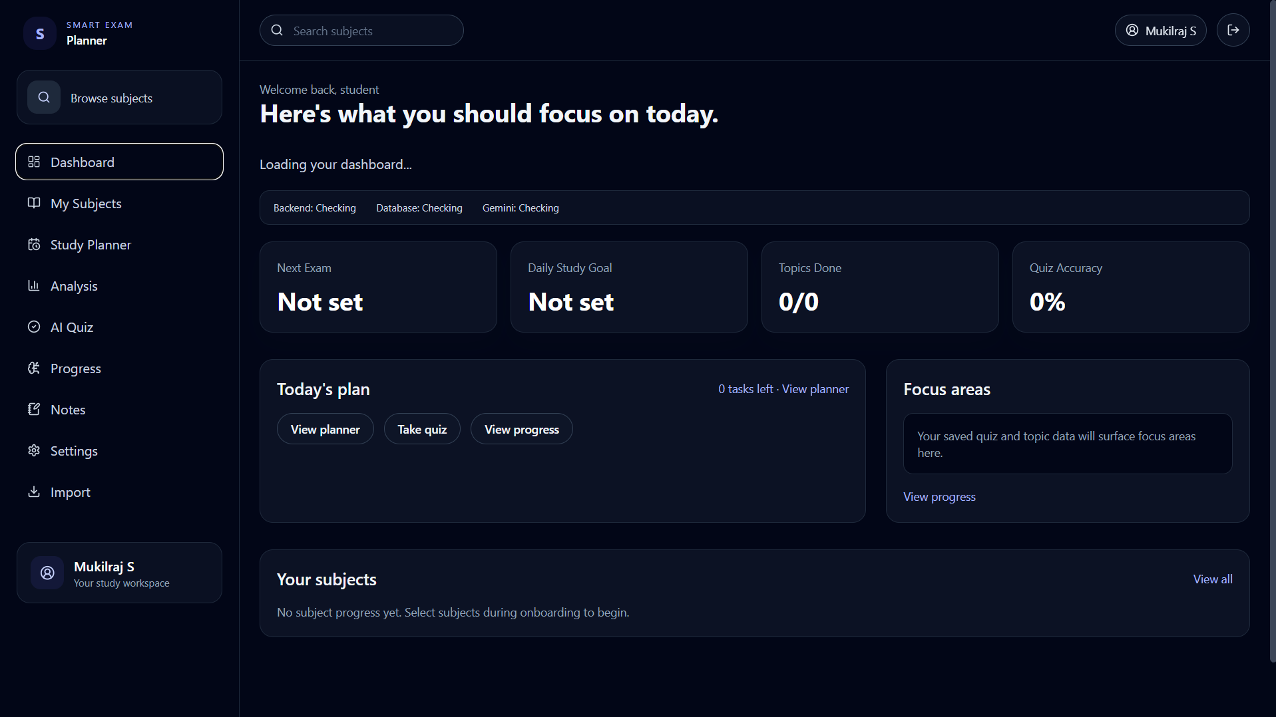

Figure 5.2.1 User Dashboard

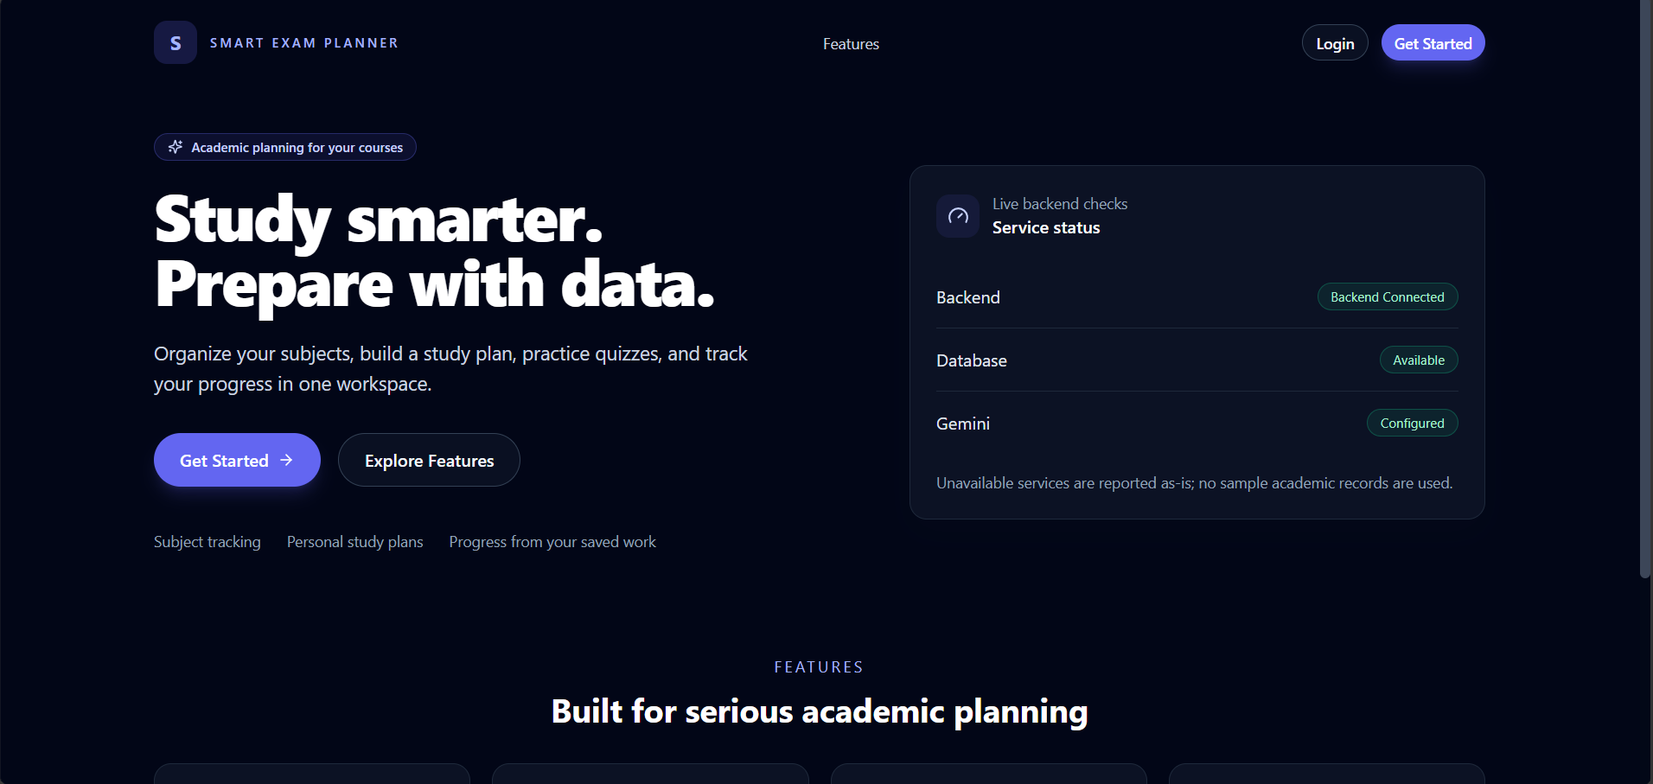
Figure 5.2.2 Login Or Registeration Page
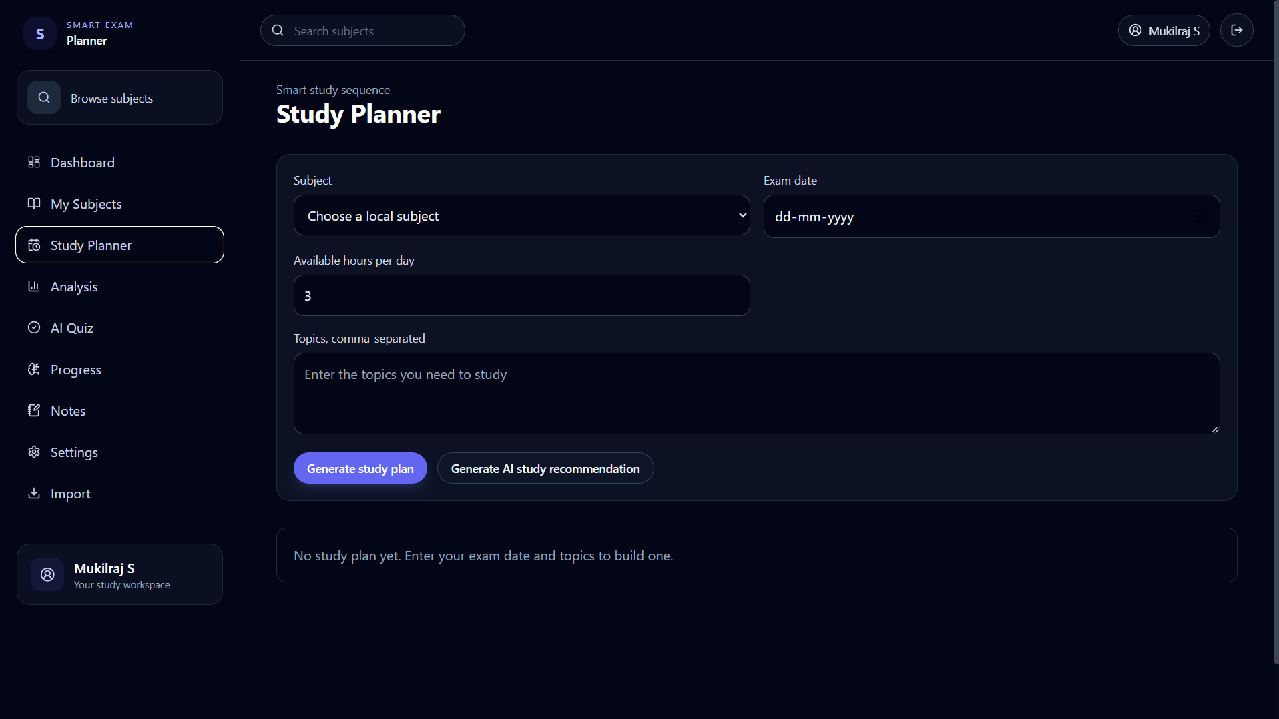

Figure 5.2.3 Study Planner

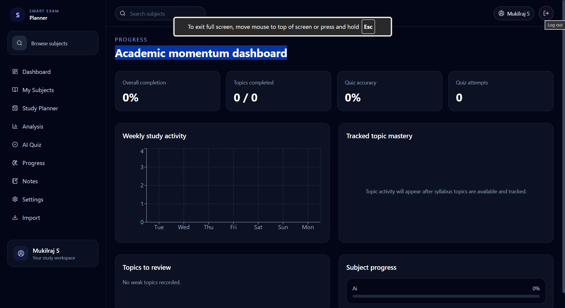

Fig 5.2.4 Academic momentum dashboard

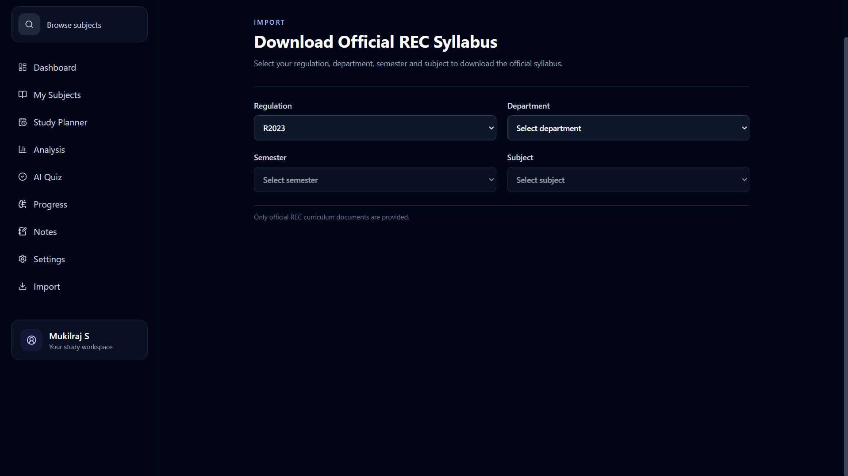
Figure 5.2.5 Download Syllabus

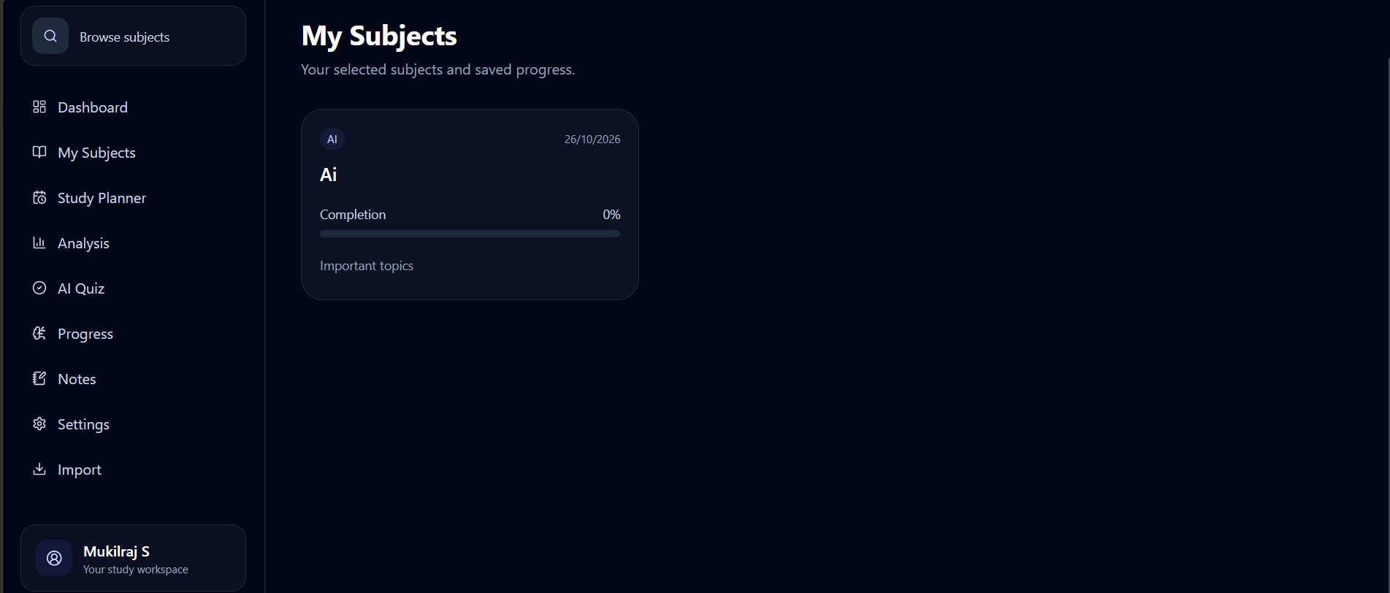

Figure 5.2.6 My Subject

5. CONCLUSION AND FUTURE WORK

The Smart Exam Planner is an AI-powered study planning system designed to make examination preparation more structured and personalized.The system integrates syllabus, notes, and previous-year question papers from RECDB and analyzes the available academic information to identify important topics and question patterns.The system separates 2-mark and 11-mark questions and provides suitable preparation activities for each category. It also generates AI-based quizzes and uses the results to identify areas requiring additional revision.

The study planner generates a day-wise preparation schedule based on topic importance, syllabus coverage, marks distribution, and examination date.The integration of AI techniques such as BFS, A Search, CSP with Backtracking, and Forward Chaining* demonstrates how Artificial Intelligence concepts can be applied to an educational planning problem.Overall, the proposed system provides students with a unified platform for analyzing academic resources, practicing important questions, and following a personalized study plan.

FUTURE WORK

The Smart Exam Planner can be enhanced with several additional features in the future.

1. Predictive Question Analysis

The system can use historical question patterns to estimate topics that require greater attention.

2. Adaptive Study Planning

The planner can automatically change the schedule based on the student's daily progress.

3. Personalized Difficulty Level

The system can generate easy, medium, and difficult quizzes based on student performance.

4. Performance Tracking

A dashboard can show:

Quiz scores

Completed topics

Remaining topics

Weak areas

Revision progress

5. Multi-Subject Planning

The system can generate one combined timetable for multiple subjects.

6. Smart Re-planning

If a student misses a study session, the system can automatically rearrange the remaining topics.

7. Mobile Application

The project can be extended into an Android or mobile application for easier access.

6. REFERENCES
- Russell, S. and Norvig, P. (2020) Artificial Intelligence: A Modern Approach, 4th Edition, Pearson.
- Cormen, T.H., Leiserson, C.E., Rivest, R.L. and Stein, C. (2022) Introduction to Algorithms, 4th Edition, MIT Press.
- Romero, C. and Ventura, S. (2020) ‘Educational Data Mining and Learning Analytics: An Updated Survey’, WIREs Data Mining and Knowledge Discovery, Vol. 10, e1355.
- Romero, C. and Ventura, S. (2013) ‘Data Mining in Education’, WIREs Data Mining and Knowledge Discovery, Vol. 3, No. 1, pp. 12–27.
- Romero, C. and Ventura, S. (2010) ‘Educational Data Mining: A Review of the State of the Art’, IEEE Transactions on Systems, Man, and Cybernetics, Part C: Applications and Reviews, Vol. 40, No. 6, pp. 601–618.
- Google, ‘Firebase Documentation’, Google Firebase, Available at: Firebase Documentation.
- Meta Platforms, Inc., ‘React Documentation’, React, Available at: React Documentation.
- Python Software Foundation, ‘Python Documentation’, Python Software Foundation, Available at: Python Documentation.
- RECDB, ‘Academic Resources Database’, Available at: RECDB, containing syllabus, unit-wise notes and previous-year question papers.
- Relevant academic resources and previous-year question papers used for question pattern analysis, topic identification and study-plan generation in the Smart Exam Planner.

